

**Module Title : COMPUTER NETWORKS**

**Assignment Title : Gotham City College: Hybrid Teaching**

**Examination Cycle : Winter 2023**

**Candidate Name : YAN LINN AUNG**

**Candidate No : P00200770**

**Centre Name : KMD COMPUTER CENTRE (YANGON)**

**Submission Date :**

**Important Notes:**

* Please refer to the Assignment Presentation Requirements for advice on how to set out your assignment. These can be found on the NCC Education *Campus*. Scroll down the left hand side of the screen until you reach Personal Support. Click on this, and then on Policies and Advice. You will find the Assignment Presentation Requirements under the Advice section.
* You must familiarise yourself with the NCC Education Academic Dishonesty and Plagiarism Policy and ensure that you acknowledge all the sources which you use in your work. The policy is available on *Campus*. Follow the instructions above, but click on Policies rather than Advice.
* You must complete the **‘Statement and Confirmation of Own Work’**. The form is available on the Policies section of *Campus*. Scroll down the left hand side until you reach Personal Support. Click on this and then click on Policies and Advice.
* Please make a note of the recommended word count. You could lose marks if you write 10%more or less than this.
* You must submit a paper copy and digital copy (on disk or similarly acceptable medium).Media containing viruses, or media which cannot be run directly, will result in a fail grade being awarded for this module.
* All electronic media will be checked for plagiarism.

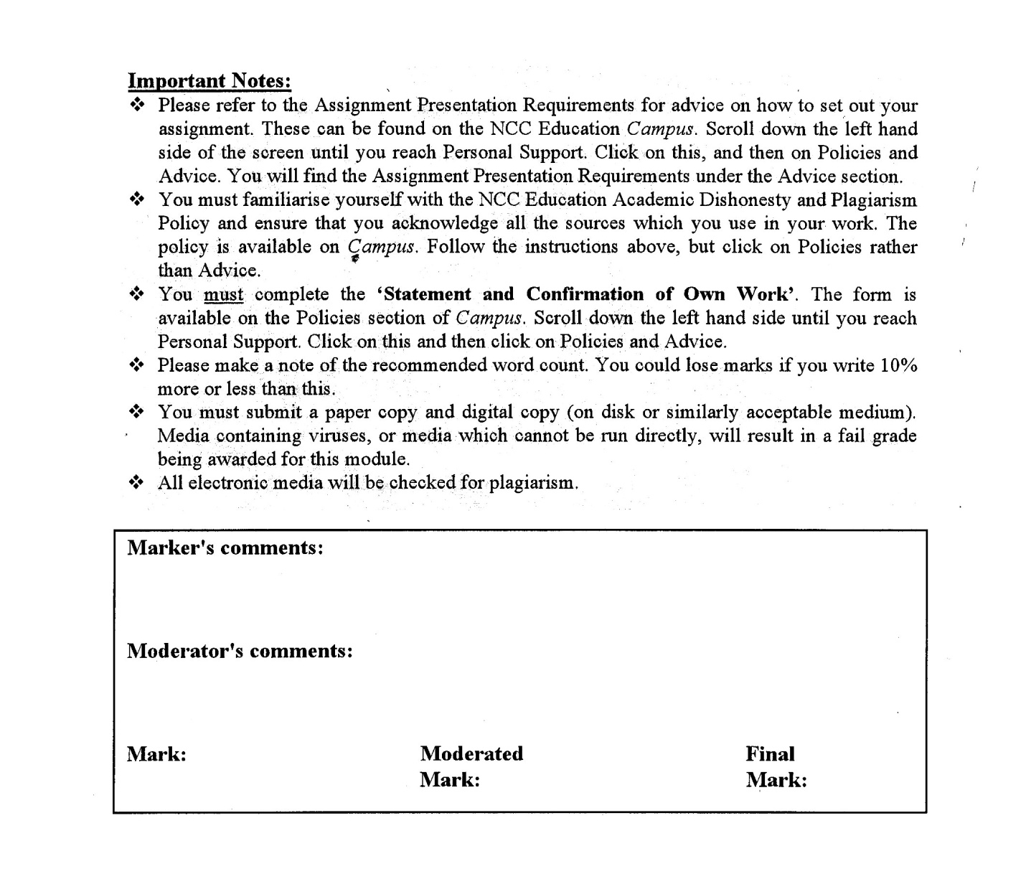



**Statement and Confirmation of Own Work**

**Programme/Qualification name: L4DC**

***All NCC Education assessed assignments submitted by students must have this statement as the cover page or it will not be accepted for marking. Please ensure that this statement is either firmly attached to the cover of the assignment or electronically inserted into the front of the assignment.***

**Student declaration**

**I have read and understood NCC Education’s Policy on Academic Dishonesty and Plagiarism.**

**I can confirm the following details.**

**Student ID/Registration number : P00200770**

**Name : YAN LINN AUNG**

**Centre Name : KMD COMPUTER CENTRE (YANGON)**

**Module Name : COMPUTER NETWORKS**

**Module Leader : HEIN SITHU NYUNT**

**Number of words : ( 3450 ) words**

**I confirm that this is my own work and that I have not plagiarised any part of it. I have also noted the assessment criteria and pass mark for assignments.**

**Due Date**  **:**

**Student Signature**  **: AUNG**

**Submission Date :**

Table of Contents

Task 1 – Planning a Network 5

Physical Topology 5

Collaboration and Communication Server 7

File Server 7

Task 2 – Wireless Networking 10

Mesh Network 10

WiFi Selection 10

Site Survey 11

PoE 12

Task 3 – Design The Network 14

Suitable IPv4 addresses for the classroom environment 15

Best Choice of Physical Cabling 15

Security considerations within the design of the network 16

Assumptions 17

Task 4 – Secure the Network 19

Advantages of implementing VPN for external users (staffs and students) 20

Task 5 – Network Operating System 22

Window Server 2022 22

Cisco IOS 23

Task 6 – Network Recommendation 25

Network Scalability 25

Three key aspects to secure the network from threats 25

Recommendations to ensure the future-proof network 26

IoT Devices 27

References 28

Candidate Checklist 33

**Task (1)**

**Planning a Network**

# Task 1 – Planning a Network

## Physical Topology

The configuration of a network’s many components is known as its physical topology. It depicts the actual configuration of the cables and equipment that make up a network. It ignores minor specifics like data transfer and device type in favor of the network’s core concerns. Depending on how simple it is to build and set up the network, nodes (computers) and network cables will be arranged in a specific layout. Depending on the device solution, it has an impact on cost and bandwidth capacity. It considers the positions of the nodes and the separations between them. Devices can be wired together in a bus topology or in a ring topology that connects them linearly. (yashchuahan, 2020) There are primarily six different types of physical topology in computer networks. These are:

- Bus Topology

- Ring Topology

- Star Topology

- Mesh Topology

- Tree (Hierarchical) Topology

- Hybrid Topology (AfterAcademy, 2020)

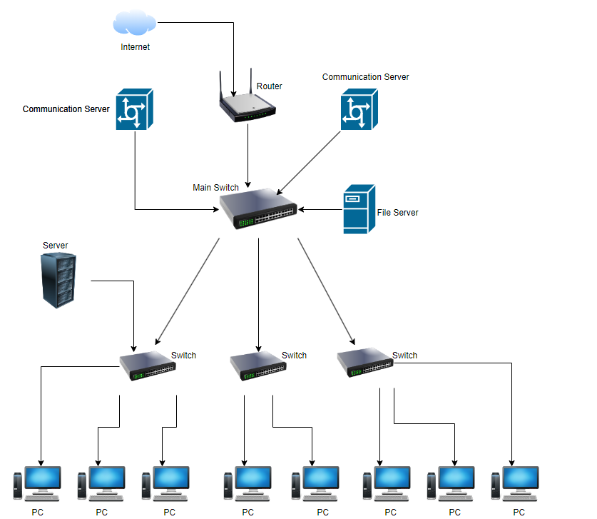

Figure 1 - Switching as Star Topology for Gotham City College

* VoIP and video conferencing systems commonly create a lot of UDP traffic since UDP is a connectionless protocol that is suitable for real-time communication applications. UDP has reduced overhead and is speedy, which is one of its main advantages. UDP is a strong fit for real-time communication applications like VoIP and video conferencing since latency (the amount of time it takes for a packet to be delivered and received) is crucial in these applications. VoIP and video conferencing systems typically employ UDP to lower latency and ensure a superior user experience. UDP is a best-effort protocol, which means that not all packets will be transmitted and that some packets may be jumbled or lost. This is important to keep in mind. VoIP and video conferencing systems commonly use error-correction and packet-loss concealment technologies to make up for this and provide a high-quality user experience.
* SolarWinds VOIP and Network Quality Manager would be the ideal software to monitor this traffic. It allows the user to keep track on WAN and VoIP call performance. VoIP metrics that may be tracked with this program include packet loss, latency, litter, and Mean Opinion Score (MOS). These metrics will alert the user if VoIP calls have poor voice and telephone quality. If a user wishes to do thorough troubleshooting, they can go through the name information to find records that can be shown that are causing poor performance. You may search for calls by name origination, name destination, name manager, name time, name status, and name quality. This makes it easier to swiftly use the troubleshooting technique. (Keary, 2023)

For use at Gotham City College, I recommend using a Collaboration and Communication Server and File Server.

## Collaboration and Communication Server

A Collaboration and Communication Server is a platform for a computing system that is used for various network communication applications and that enables suppliers to add numerous values at various architectural levels. The network infrastructure needed to establish communication technologies, such as wireless, broadband, or IP-multimedia, is built on a communications server, which is the cornerstone for equipment manufacturers or suppliers. Communications servers have been extensively supported by the IT and communications sectors. (Rouse, 2011)

The location of the communication server can be within the same structure or on different continents. Through a network connection, they link to the systems they want to communicate with. There are occasions when a communication server is linked to additional servers that are linked together in a chain. It functions as a bridge between two or more systems, allowing them to communicate with each other using the proper protocol and application. The many roles of a communication server require that it be accessible. Both it and the industry-standard software it supports must be able to use numerous protocols. It must also have the ability to link to a range of other systems. Even something as basic as a router or a communications network might operate as a communication server. Each situation involves the same fundamental operations of a communication service. The method of data storage has changed. (Veloce Network, 2023)

As a Hybrid Teaching College, it is essential to use the Collaboration and Communication Server. There are many types of using Collaboration and Communication Server. These are VoIP (Voice over Internet Protocol), Email Servers, Instant Messaging Servers, Video Conferencing Servers, and Unified Communication Server. (Veloce Network, 2023) File Transfer Protocol (FTP), TCP/IP, User Datagram Protocol (UDP), Hypertext Transfer Protocol (HTTP), Post Office Protocol (POP3), Internet Message Access Protocol (IMAP), Simple Mail Transfer Protocol (SMTP) are protocols of a Collaboration and Communication Server. (Rouse, 2023)

## File Server

A file server is a computer that manages and stores data files so that other computers connected to the same network can access them. Without physically transferring files, it lets users to communicate information over a network. (Wright, 2021) The Types of file server are Dedicated File Server and Non-Dedicated File Server. (chaudharyankitaa55, 2022) For Gotham City College, a file server makes it easy to share folders and files internally with students, educators, and staff members. File sharing options include transmitting files directly over the Internet or transferring them first to a cloud storage server online. The most effective share file servers will adopt a hybrid approach, which means they operate on both on-premises and cloud servers. For busy students and teachers who want to start sharing right away, an integrated solution is perfect because no one has to learn how to utilize the application. (Dunlop, 2021)

Server message block (SMB), Network File System (NFS), File Transfer Protocol (FTP), and Secure FTP (SFTP) are protocols of a file server. (Wright, 2021)

**Task (2)**

**Wireless Networking**

# Task 2 – Wireless Networking

## Mesh Network

A mesh network is a network in which nodes or devices are connected to one another and branch out to other nodes or devices. These networks are designed to transport data between devices and clients effectively. They assist businesses in establishing a constant link throughout a physical area. Mesh network topologies design several paths for data to transit between linked nodes. By using this strategy, the network will be more resilient in the event of node or connection failure. Multiple routers, switches, and other devices that function as nodes may be used in larger mesh networks. A mesh network may cover a huge area since it can have hundreds of wireless mesh nodes. (Gillis, 2021)

**Types of Mesh Network**

* Wi-Fi Mesh Network
* Wired Mesh Network
* Full Mesh Topology Network
* Partial Mesh Topology Network
* Hybrid Mesh Network
* Infrastructure Mesh Architecture Network
* Client-Bases Mesh Architecture Network (BasuMallick, 2022)

## WiFi Selection

For this case of scenario, WiFi 6 (802.11ax) is a superior option since it offers higher performance and can manage the needs of a high-density area better. The newest WiFi technology, WiFi 6, was created to outperform WiFi 5 in locations within a high density of devices. WiFi 6 is better suited for usage in classrooms where there may be numerous devices connected to the network at once since it has increased range and coverage, quicker speeds, reduced latency, and greater power economy than WiFi 5. Additionally, WiFi 6 uses less power than WiFi 5, allowing it to operate for longer on a single day’s battery. (Stone, 2020)

## Site Survey

In order to develop and construct a wireless network, a site survey is a technique that is used to evaluate the wireless coverage and performance of a specific area, such as an office or classroom. In order to make sure that the network is planned and implemented in a way that fits the demands of the users and the environment, site surveys are often carried out prior to the installation of wireless access points (WAPs).

There are several reasons why site surveys are important when installing wireless access points-

* To access the coverage and capacity needs of the location: The number and position of wireless access points required to offers sufficient coverage and capacity for the users in the area may be determined with the use of a site survey. Making ensuring the wireless network can support the anticipated number of devices and the anticipated range of application types is crucial.
* To identify potential interference and obstacles: The performance of the wireless network may be impacted by sources of interference, such as other wireless devices or actual impediments like walls and floors, which may be found during a site inspection. The wireless access points may be configured with the optimal frequency band and channel using this information.
* To ensure compliance with regulations: When building wireless access points, there may occasionally be legal regulations that must be followed. A site survey can assist make sure that the wireless network is developed and installed in accordance with these rules.
* To optimize performance and user experience: A network may be adjusted for the optimum performance and user experience by identifying locations where the wireless signal may be weak or inconsistent with the aid of a site assessment.

**Types of Wireless Site Survey:**

1. Predictive Site Survey
2. Passive Site Survey
3. Active Site Survey
4. Hybrid Site Survey

To conclude, site surveys are a crucial phase in the installation of wireless access points because they make sure that the network is planned and implemented to satisfy the requirements of the site and its users. (Ridzyowski, 2021) (SONICWALL, 2020) (ACCESSAGILITY, 2022)

## PoE

Power over Ethernet (PoE) is technology that transmits electrical power together with the data that twisted-pair Ethernet cable typically transports to powered devices (PD), such as VoIP phones, IP cameras, and wireless access points. Instead of having separate cables for each, it makes it possible to power and connect data to PDs with a single RJ45 wire. (Intellinet Network Solutions, 2023)

There are several benefits to installing PoE enabled access points in an enterprise environment-

1. Flexibility: Devices like IP cameras and wireless access points may be placed wherever they are most needed and moved quickly if necessary since they are not tied to an electrical outlet. (Veracity, 2016)
2. Time and cost savings: by reducing the time and cost associated with installing electrical power wiring. Network cables may be found everywhere and don’t need to be installed by a licensed electrician. (Veracity, 2016)

**Task (3)**

**Design the Network**

# Task 3 – Design The Network

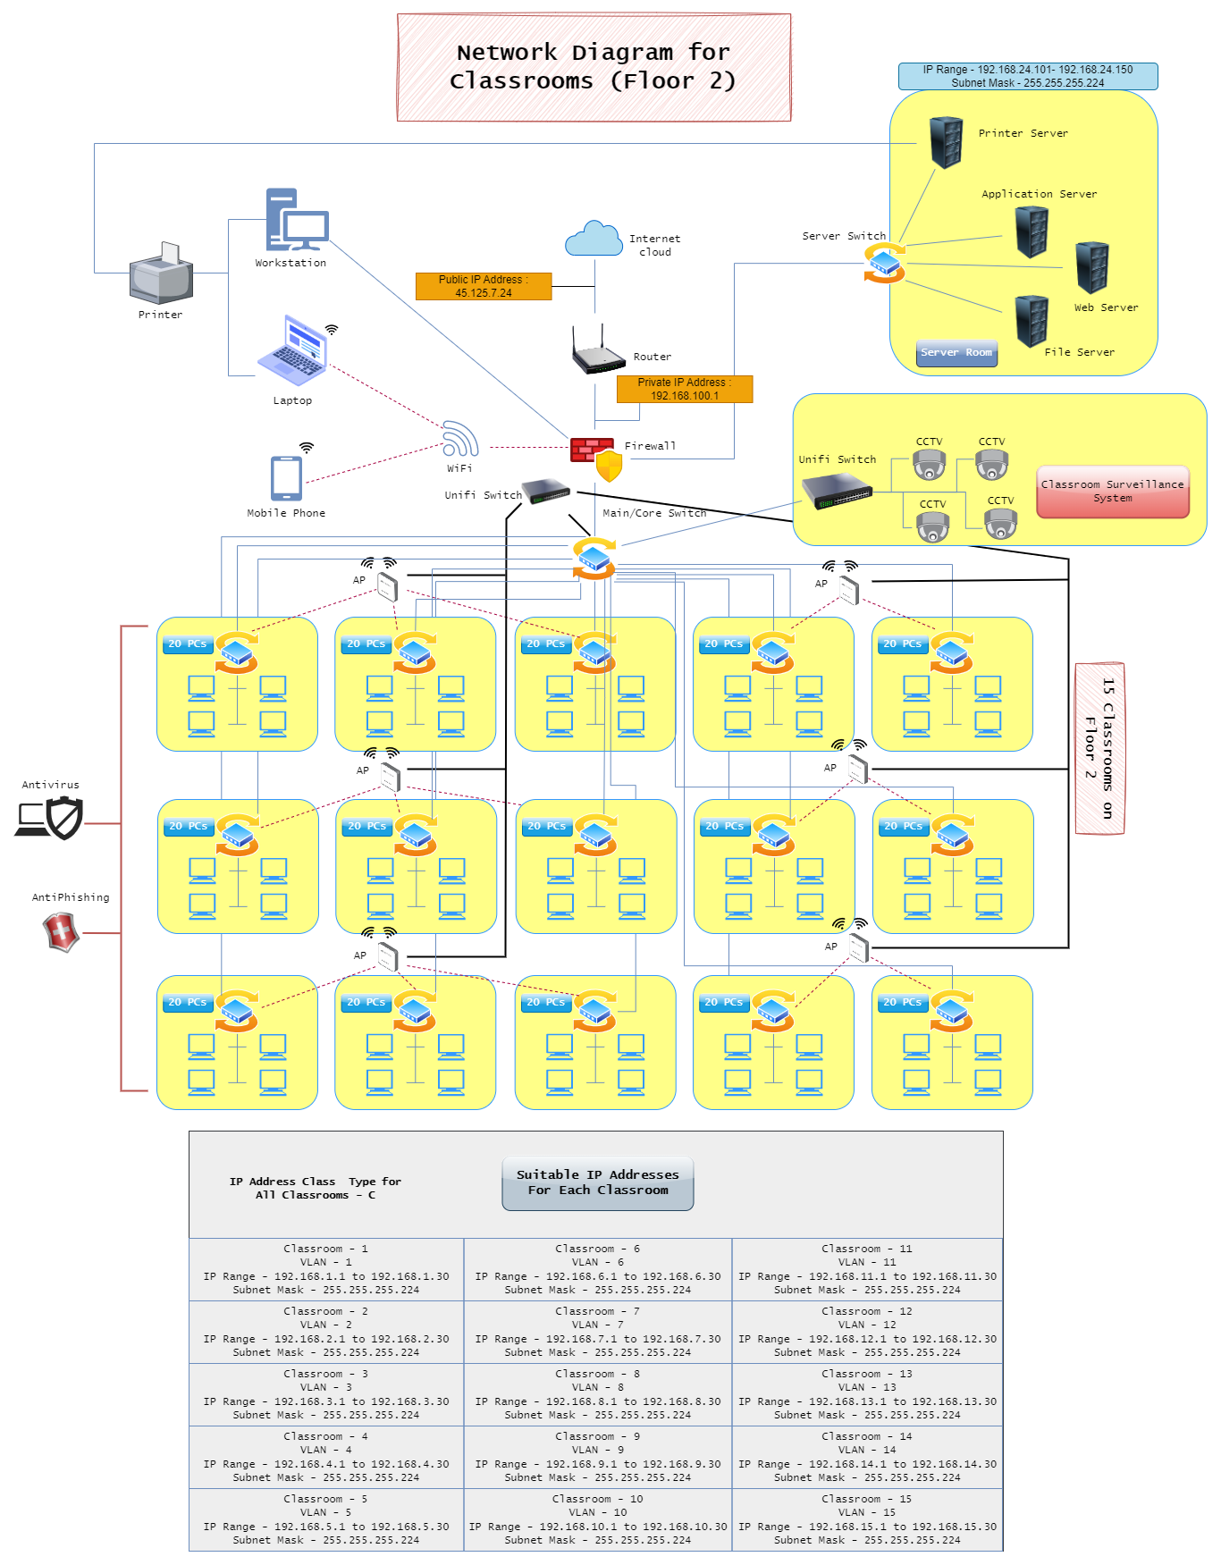

Figure 2 - Diagram of illustration for the classroom network design

## Suitable IPv4 addresses for the classroom environment

For 15 classrooms, IPv4 based addresses (Type C) are selected. In order for devices connected to a local network in classrooms to interact with one another, private IP addresses are utilized. Private IP addresses are used for devices inside a local network, like Gotham City College, and are not routed on the internet. Private IP addresses of type C in the range 192.168.0.0 to 192.168.255.255 are chosen for this assignment. This gives the instructor more control over the network and enables devices in the same classroom to connect with one another but not with those on different networks.

## Best Choice of Physical Cabling

There are several Ethernet cables available that might be used in a classroom environment and offer a quick, dependable connection at a reasonable cost. For Gotham City College, Cat 6 cable is selected.

Unshielded twisted-pair (UTP) Cat 6 cables can transport data at speeds of up to 10 Gbps (gigabits per second) across short distances, making them ideal for most classroom applications. They were created as an upgrade to UTP Cat 5e cables. They start at about $1 per foot, making them also reasonably priced. (Rouse, 2013)

On choosing Cat 6 cable, it is important to make sure that the cable is long enough to reach all of the network's devices, constructed from high-quality materials, and qualified for usage in high-speed networks. By doing this, the wires' dependability and toughness will be increased. Some Cat 6 cables contain shielded twisted pairs or enhanced interference protection, which can aid with performance and lower the chance of data loss. (RS, 2023) Particularly for applications that demand a consistent and dependable connection, these qualities could be worthwhile to take into account. Therefore, Cat 6 cable is a cost-effective and reliable choice for classroom networks that meets Gotham City College’s needs and budget.

## Security considerations within the design of the network

For the classroom of Floor 2, there are three security systems:

**Firewall**

A firewall is a type of network security system that keeps an eye on and regulates incoming and outgoing network traffic in accordance with pre-established security rules. It can aid in preventing unwanted access to the network and safeguard against online dangers like viruses and malware. Furthermore, Next Generation Firewalls are a particular class of firewall that, in addition to blocking malware and application-layer assaults, also has an integrated intrusion prevention system (IPS) that enables it to instantly identify and address external threats across the whole network. The network may be better protected by configuring these firewalls with particular policies, and they can do quick assessments to find and stop any potentially harmful behavior, such as malware. (Check Point, 1994-2023)

**Network access control (NAC)**

Systems for network access control (NAC) can be used to limit network access depending on a user's identification or device. This can aid in preventing both unauthorized people from joining to the network and the connection of devices that do not adhere to particular security requirements. Gotham City College may better manage network access, maintain compliance, and fortify their IT infrastructure with the use of NAC solutions and technologies. (Awati, 2023)

**Antivirus Software**

All network-connected devices may be protected against malware and other online dangers by installing antivirus software. Antivirus software operates by searching a device's files and applications for known malware and disabling any that it discovers. To make sure that the software is able to recognize and stop the most recent threats, it is crucial to keep it updated. Kaspersky was chosen for the software because it provides real-time security, virus elimination, and browser filtering. (Kaspersky, 2019)

## Assumptions

For the network design of the classrooms, IPv4 class C is selected. Since classroom are small to medium sized network, class C can used. There are some advantages of using IPv4 class C, small, compatible, easy to recognize and efficient. CCTVs are installed to monitor students’ behavior and to ensure the safety of students, teachers and staffs. Also, for the security measures, firewall and antivirus plays a big role for the college. And, Kaspersky and Cat 6 cables are selected within the affordable price range to meet the college’s budget. Classroom PCs can access the servers easily and efficiently since they have permitted IP addresses within the network. Classroom network is modernly designed to process well.

**Task (4)**

**Securing the Network**

# Task 4 – Secure the Network

Three common network threats

* Virus
* Trojan
* Phishing

**Virus**

A virus is a type of malicious computer code that is intended to propagate from one device to another or throughout a network. Email attachments, infected software downloads from dubious or dangerous websites, and USB devices are among of the ways malware travels across computer systems and modifies how they operate. If a device is infected, the virus can cause several problems -

* Deleting or corrupting files on the infected device
* Slowing down the performance of the infected device
* Stealing private information, such as personal accounts or financial information
* Using the infected device spread viruses on other devices within the network. (WEBROOT, 2023)

**Effective countermeasure**

Using Antivirus software: This can aid in the detection, prevention, and elimination of viruses from computer systems and networks. To find and stop viral attacks, antivirus software employs signature-based and behavior-based detections. To stop malware like viruses, most of them offer real-time protection and automated upgrades. ( Verizon, 2023)

Additionally, firewalls can stop harmful and unauthorized traffic from entering the network. As a result, installing a firewall on the system is another option for virus defense.

**Trojan**

A Trojan, commonly referred to as a Trojan horse, is a form of malware that impersonates a trustworthy software or file to enter the computer and take over. Although a Trojan does not replicate itself as a virus does, it can nevertheless seriously harm a computer or network. Trojans frequently propagate via email attachments, corrupted software downloads, or by exploiting system flaws. (Johansen, 2020) (Imperva, 2023)

**Effective countermeasure**

Updating the OS and software regularly: To combat the known vulnerabilities that Trojans would develop, this might be helpful by obtaining the most recent security updates. Avoiding downloading or installing software from sources you can't entirely trust is another aspect of countermeasures to think about. (WEBROOT, 2023) Also, powerful antivirus software can detect and prevent against Trojans.

**Phishing**

Phishing is a technique used by hackers to get private information by posing as a reliable source. The user is tricked into taking activities like installing malware, clicking on links, or providing personal information through messages that may contain dangerous links or files. A common method of social engineering, which broadly refers to attempts to trick computer users, is phishing. Social engineering, including phishing, is a frequent threat vector used in almost all types of cyber incidents. (Check Point, 1994-2023)

**Effective countermeasure**

Awareness: This is important since avoiding phishing attacks requires being vigilant when dealing with questionable emails, texts, calls, and URLs. Phishing attempts may be found and stopped with anti-phishing software. (Check Point, 1994-2023)

## Advantages of implementing VPN for external users (staffs and students)

* Optimized security: VPNs may encrypt internet traffic, making it more difficult for hackers to intercept or steal private data.
* Prevent data throttling: It occurs when the defined data has been used up by the users to a certain point and the ISP may impede service. By using a VPN, it is possible to prevent the ISP from learning how much data is being consumed. (Fortinet, 2023)
* Remote access: When students are away from school and at off-campus locations, VPN can enable them to securely access college resources like library databases and internal websites.
* Bypassing restrictions: Users who use a VPN can access blocked websites by avoiding internet censorship and geo-restrictions. (A, 2023)

**Task (5)**

**Network Operating Systems**

# Task 5 – Network Operating System

## Window Server 2022

Windows Server 2022 incorporates updates to its server OS and has built-in functionality for configuring and administering file sharing, DNS, and DHCP services. Both the Domain Name System (DNS) role and the File and Storage Services role may be used to configure file sharing and DNS services, respectively.

**File Sharing:** Windows Server 2022 is equipped with a variety of powerful enterprise features that allow IT administrators to establish resilient and highly available infrastructure services. Transparent failover is one such capability that enables administrators to employ SMB (Server Message Block) 3.0 and above capabilities to lessen file transmission bottlenecks. (Lee, 2022)

**DNS:** The Domain Name System is a naming database that records data on domains and their unique IP addresses. It transforms website URLs into machine-understandable IP addresses, making user access simpler and more effective. (Jethva, 2022) On Windows Server 2022, DNS can be installed. Administrators may establish rules and settings by creating and managing DNS policies with Windows Server 2022.

**DHCP:** By installing and configuring the DHCP role, Windows Server 2022 may be made to function as a DHCP (Dynamic Host Configuration Protocol) server. As a result, the server may give network clients IP addresses and other network parameters. (DHCP Server, 2022) Following installation, the DHCP role may be configured to control IP assignments within a certain range, define DHCP options, and reserve DHCP for particular customers.

**Disadvantages**

**Cost:** Windows Server 2022 requires a license purchase in order to utilize. For Gotham City College, the Data Server edition could be a touch pricey at $6155 as opposed to the normal version's $1069 price. (Alexissadie, 2022)

**Complexity:** Due to the complexity of the OS, clients who are not familiar with it may find it difficult to operate.

**Compatibility issues:** It contradicts and conflicts with the idea of open-source software. There is a chance that certain software or programs will function effectively on Windows Server 2022. (Alexissadie, 2022)

## Cisco IOS

Cisco IOS is a proprietary operating system that is used on Cisco routers and switches to enable communication between network nodes. It has several features, including routing and switching, encryption, authentication, firewalls, policy enforcement, deep packet inspection, quality of service, intelligent routing, and proxy capabilities. It may also handle call processing and unified communications in Cisco's Integrated Services Routers (ISRs). Cisco IOS software is released in "families" and "trains", with each family sharing a common code base and releases delivered through trains. (Scarpati, 2000-2023) Its fundamental objective is to make Cisco equipment configurable and manageable, enabling the development and upkeep of a reliable and secure network infrastructure.

Cisco IOS can be installed on Cisco network devices such as –

* Routers
* Switches
* Access Points

**Task (6)**

**Network Recommendation**

# Task 6 – Network Recommendation

## Network Scalability

The ability of a network to grow to handle an increase in users, devices, and transactions without performance degradation is referred to as network scalability. In general, network scalability refers to the network's capacity to manage growing demands for processing, data storage, traffic volume, and internet users. It also refers to the network's capacity to add additional nodes as required. (Network Security, 2023) If the network system for this assignment has expanded in any way, it is meant to be scalable and capable of supporting a high number of users.

* Using a wired network infrastructure: Ethernet cables provide a higher bandwidth capacity than wireless connections, which can assist to ease congestion and boost performance for more devices. Since Cat6 cables are utilized, they are essentially scalable if internet traffic increases. Additionally, Cat6 cables have high performance and bandwidth capabilities, thus these cables are thought to be put in classrooms.
* Installing VLANs (Virtual LANs): This allows to segment the network into different sub-networks, each with its own set of rules and policies. Additionally, it can assist to increase security and lessen congestion, which results in packet loss.
* Using switches: In order to boost the network's scalability, a switch with multiple ports will enable the connection of additional devices.

## Three key aspects to secure the network from threats

1. Antivirus software: A variety of strategies are used by these to defend against attacks, including real-time protection to stop and block potential threats as they develop and file scanning for known malware threats. Antivirus software can help protect from viruses, spyware, ransomware, worms and trojans.
2. Firewall: It can serve as a gatekeeper, keeping an eye on all attempts to reach the network system and blocking unwanted traffic from unknown sources. In essence, a firewall acts as a barrier between the computer and the internet. Since it manages network traffic to maintain network security, it can shield typical threats that might cause problems for the computers in Gotham City College classrooms. This entails filtering out incoming network traffic that wasn't requested and validating access by scanning it for malware and other harmful network traffic. (Stouffer, 2023)
3. Anti-Phishing Software: They are computer applications that are used to recognize and prevent phishing information in email attachments and websites. They have technology that blocks suspicious URLs and messages from email attachments as well as certain spam that may be phishing or impersonation attacks. Some anti-phishing software can teach users how to spot phishing assaults. Combining anti-phishing software with training can assist to provide protection. (mimecast, 2003-2023)

## Recommendations to ensure the future-proof network

Bandwidth plays a crucial role. In order to allow the college's vast population of internet users to continue using the internet, the network has to be promptly upgraded. Gotham City College's classrooms have WiFi 6 (802.11ax) installed. 9.6Gbps is the WiFi 6 standard's maximum speed. However, the real advantage is that it can process more device requests concurrently, preventing the network from being slower as more devices are added. In addition to making better use of spatial radio resources, Wi-Fi 6 improves multi-user concurrency per unit coverage area. As a result, it may be considered to be network-proof in the future.

In order to make the network system future-proof, security is another factor. The installation of several firewalls can contribute to the prevention of digital assets, including network and data. Unauthorized users would therefore have a difficult time accessing confidential data (such as student, staff, and college data and financial information).

An alternative to employing switches, routers, and cables to route network traffic across several devices in a network is called SD-WAN (Software Defined Wide Area Network). Additionally, it offers cloud-based network monitoring and has tools for setting up the network to meet the requirements of the college. (Capcon Networks, 2023)

To sum up, it is advised to consider these three aspects in order to future-proof Gotham City College's network.

## IoT Devices

The Internet of Things (IoT) is a network of physical objects that include sensors, software, and connection to gather and share data. IoT enables the efficient remote sensing and control of things inside the network system as well as the direct integration of physical objects into computer-based systems. (IBM, 2023) However, there are risks to use the IoT devices.

Device identification is the first step. Devices for connecting to the network should be chosen before usage in the college network. The second need is network connectivity for the devices. It is necessary to setup the proper parameters, including IP addresses and login credentials. Thirdly, up-to-date software has to be installed. Finally, those gadgets need to be protected and watched over.

Here are the three risks of IoT devices –

* Security: IoT devices typically have weak security systems, making them susceptible to hacking and other online attacks. This might cause data leaks and harm the devices' functionality.
* Awareness: Users of IoT devices are still not well-informed. The majority of this comes from the producers, but consumers still don't take safeguards, therefore greater hazards like cyber assaults can occur. (Micro.ai, 2023)
* Lack of Encryption: The bulk of IoT users have this problem. The communications cannot be encrypted. This implies that private information may be taken if an attacker hacks into the system of the gadget. (Micro.ai, 2023)

# References

Verizon, 2023. *Antivirus | Verizon.* [Online]   
Available at: https://www.verizon.com/articles/internet-essentials/antivirus-definition/  
[Accessed 16 September 2023].

ACCESSAGILITY, 2022. *Why is a Wireless Site Survey needed? How does it help? | ACCESSAGILITY.* [Online]   
Available at: https://www.accessagility.com/blog/why-is-a-wireless-site-survey-needed-how-does-it-help  
[Accessed 2 September 2023].

AfterAcademy, 2020. *What is network topology and types of network topology? | AfterAcademy.* [Online]   
Available at: https://afteracademy.com/blog/what-is-network-topology-and-types-of-network-topology/  
[Accessed 25 August 2023].

Alexissadie, 2022. *Major Pros and Cons of using Windows Hosting in 2022 | HackMD.* [Online]   
Available at: https://hackmd.io/@alexissadie/major-pros-and-cons-of-using-windows-hosting-in-2022  
[Accessed 26 September 2023].

Awati, R., 2023. *What is network access control (NAC) | TechTarget.* [Online]   
Available at: https://www.techtarget.com/searchnetworking/definition/network-access-control  
[Accessed 15 September 2023].

A, Z., 2023. *What Are the Advantages and Disadvantages of a VPN? | Security Gladiators.* [Online]   
Available at: https://securitygladiators.com/vpn/advantages-disadvantages/  
[Accessed 16 September 2023].

BasuMallick, C., 2022. *What Is a Mesh Network? Meaning, Types Working, and Applications in 2022 | spiceworks.* [Online]   
Available at: https://www.spiceworks.com/tech/networking/articles/what-is-mesh-network/  
[Accessed 1 September 2023].

Capcon Networks, 2023. *SD-WAN 101 | Capcon Networks.* [Online]   
Available at: https://www.capconnetworks.com/future-proof-your-network-with-sd-wan#:~:text=SD%2DWAN%20stands%20for%20Software,variety%20of%20devices%20and%20connections.  
[Accessed 5 October 2023].

chaudharyankitaa55, 2022. *Type of File Server | GeeksforGeeks.* [Online]   
Available at: https://www.geeksforgeeks.org/what-is-file-server/  
[Accessed 26 August 2023].

Check Point, 1994-2023. *What is a Firewall | Check Point.* [Online]   
Available at: https://www.checkpoint.com/cyber-hub/network-security/what-is-firewall/  
[Accessed 15 September 2023].

Check Point, 1994-2023. *What is Phishing? | Check Point.* [Online]   
Available at: https://www.checkpoint.com/cyber-hub/threat-prevention/what-is-phishing/  
[Accessed 16 September 2023].

DHCP Server, 2022. *DHCP Server for Windows | DHCP Server.* [Online]   
Available at: https://www.dhcpserver.de/cms/  
[Accessed 25 September 2023].

Dunlop, M., 2021. *How Does a Share File Server Work? | eLearning Inside.* [Online]   
Available at: https://news.elearninginside.com/the-benefits-of-using-a-share-file-server-in-education/  
[Accessed 26 August 2023].

Fortinet, 2023. *Benefits of a VPN | Fortinet.* [Online]   
Available at: https://www.fortinet.com/resources/cyberglossary/benefits-of-vpn  
[Accessed 16 September 2023].

Gillis, A. S., 2021. *Mesh Network Topology | TechTarget.* [Online]   
Available at: https://www.techtarget.com/iotagenda/definition/mesh-network-topology-mesh-network  
[Accessed 1 September 2023].

IBM, 2023. *What is the internet of things? | IBM.* [Online]   
Available at: https://www.ibm.com/blogs/internet-of-things/what-is-the-iot/  
[Accessed 5 October 2023].

Imperva, 2023. *What Is a Trojan Virus | Imperva.* [Online]   
Available at: https://www.imperva.com/learn/application-security/trojans/  
[Accessed 16 September 2023].

Intellinet Network Solutions, 2023. *What is Power over Ethernet (PoE)? | Intellinet Network Solutions.* [Online]   
Available at: https://intellinetnetwork.eu/pages/power-over-ethernet  
[Accessed 3 September 2023].

Jethva, H., 2022. *How to Setup Windows DNS Server and Configuration on Windows 2022 | Cloud Infrastructure Services.* [Online]   
Available at: https://cloudinfrastructureservices.co.uk/how-to-setup-windows-dns-server-and-configuration-on-windows-2022/  
[Accessed 25 September 2023].

Johansen, A. G., 2020. *What is a Trojan? Is it a viorus or is it malware? | Norton.* [Online]   
Available at: https://us.norton.com/blog/malware/what-is-a-trojan  
[Accessed 16 September 2023].

Kaspersky, 2019. *About Kaspersky Anti-Virus.* [Online]   
Available at: https://support.kaspersky.com/KAV/2020/en-us/87342.htm  
[Accessed 15 September 2023].

Keary, T., 2023. *The Best VoIP Monitoring Tools & Software for 2023 | Comparitech.* [Online]   
Available at: https://www.comparitech.com/net-admin/best-voip-monitoring-tools/  
[Accessed 25 August 2023].

Lee, B., 2022. *Setting up highly available file shares in Windows Server 2022 | 4sysops.* [Online]   
Available at: https://4sysops.com/archives/setting-up-highly-available-file-shares-in-windows-server-2022/  
[Accessed 25 September 2023].

Micro.ai, 2023. *IoT Security – The Top Six Risks | Micro.ai.* [Online]   
Available at: https://micro.ai/blog/iot-security-the-top-six-risks  
[Accessed 5 October 2023].

mimecast, 2003-2023. *Anti-Phishing | mimecast.* [Online]   
Available at: https://www.mimecast.com/content/anti-phishing/  
[Accessed 5 October 2023].

Network Security, 2023. *Scalability | Network Security.* [Online]   
Available at: https://www.networxsecurity.org/members-area/glossary/s/scalability.html  
[Accessed 5 October 2023].

Ridzyowski, T., 2021. *WHY DO YOU NEED A WIRELESS SITE SURVEY? | TURN-KEY TECHNOLOGIES.* [Online]   
Available at: https://www.turn-keytechnologies.com/blog/article/why-do-you-need-a-wireless-site-survey/  
[Accessed 2 September 2023].

Rouse, M., 2011. *Communications Server | Techopedia.* [Online]   
Available at: https://www.techopedia.com/definition/18429/communications-server#:~:text=A%20communications%20server%20is%20a,at%20different%20levels%20of%20architecture.  
[Accessed 25 August 2023].

Rouse, M., 2013. *Category 6 Cable (Cat 6 Cable) | Techopedia.* [Online]   
Available at: https://www.techopedia.com/definition/17070/category-6-cable-cat-6-cable  
[Accessed 10 September 2023].

Rouse, M., 2023. *Communication Protocol | Techopedia.* [Online]   
Available at: https://www.techopedia.com/definition/25705/communication-protocol#:~:text=Popular%20protocols%20include%3A%20File%20Transfer,Mail%20Transfer%20Protocol%20(SMTP).  
[Accessed 26 August 2023].

RS, 2023. *Cat6 Cable Guide | RS.* [Online]   
Available at: https://uk.rs-online.com/web/content/discovery/ideas-and-advice/cat6-cable-guide  
[Accessed 10 September 2023].

Scarpati, J., 2000-2023. *Cisco IOS (Cisco Internetwork Operating System) | TechTarget.* [Online]   
Available at: https://www.techtarget.com/searchnetworking/definition/Cisco-IOS-Cisco-Internetwork-Operating-System  
[Accessed 27 September 2023].

SONICWALL, 2020. *Why is a Wireless Site Survey needed? | SONICWALL.* [Online]   
Available at: https://www.sonicwall.com/support/knowledge-base/why-is-a-wireless-site-survey-needed/170503717715599/#:~:text=A%20wireless%20site%20survey%20helps,complaints%20about%20bad%20WiFi%20access.  
[Accessed 2 September 2023].

Stone, A., 2020. *How WiFi 6 is Helping Schools Stay Connected | EdTech.* [Online]   
Available at: https://edtechmagazine.com/k12/article/2020/03/how-wi-fi-6-helping-schools-stay-connected  
[Accessed 1 September 2023].

Stouffer, C., 2023. *What is a firewall? Firewalls explained and why you need one | norton.* [Online]   
Available at: https://us.norton.com/blog/privacy/firewall  
[Accessed 5 October 2023].

Veloce Network, 2023. *What is a Communication Server? | Veloce Network.* [Online]   
Available at: https://www.velocenetwork.com/tech/what-is-a-communication-server/  
[Accessed 25 August 2023].

Veracity, 2016. *Why use PoE? | Veracity.* [Online]   
Available at: https://www.veracityglobal.com/resources/articles-and-white-papers/poe-explained-part-1.aspx  
[Accessed 3 September 2023].

WEBROOT, 2023. *What is a Computer Virus and How Can I Protect My Computer? | WEBROOT.* [Online]   
Available at: https://www.webroot.com/us/en/resources/tips-articles/computer-security-threats-computer-viruses  
[Accessed 16 September 2023].

WEBROOT, 2023. *What is a Trojan Virus? | WEBROOT.* [Online]   
Available at: https://www.webroot.com/us/en/resources/tips-articles/what-is-trojan-virus  
[Accessed 16 September 2023].

Wright, G., 2021. *What is a file server and how does it work? | TechTarget.* [Online]   
Available at: https://www.techtarget.com/searchnetworking/definition/file-server  
[Accessed 26 August 2023].

yashchuahan, 2020. *Difference between Physical and Logical Topology | GeeksforGeeks.* [Online]   
Available at: https://www.geeksforgeeks.org/difference-between-physical-and-logical-topology/  
[Accessed 25 August 2023].

# Candidate Checklist

Please use the following checklist to ensure that your work is ready for submission.



Have you read the NCC Education documents 'What is Academic Misconduct? Guidance for Candidates' and 'Avoiding Plagiarism and Collusion: Guidance for Candidates' and ensured that you have acknowledge all the sources that you have used in your work?



Have you completed the 'Statement and Confirmation of Own Work' form and attached it to your assignment? **You must do this**.

Have you ensured that your work has not gone over or under the recommended word count by more than 10%?



Have you ensured that your work does not contain viruses and can be run directly?

